**Practical No. 8**

**Aim:** Create a simple hello world app in google app engine

**Steps:**

Step 1: Download and Install Google Cloud SDK

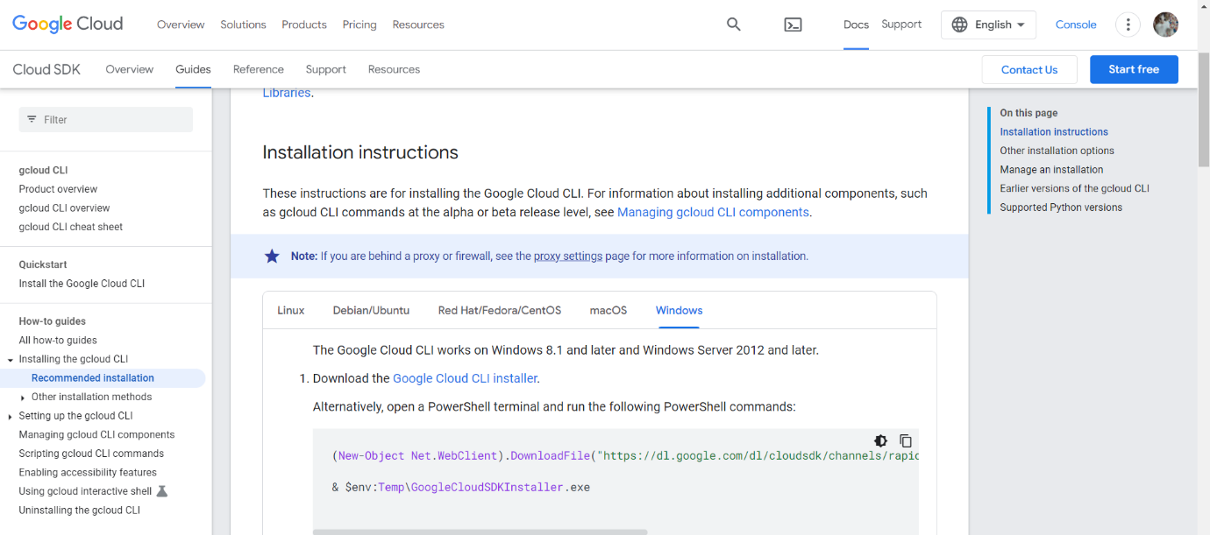

Step 2: Create a "Hello, World!" Python App

Create a New Directory: Open your terminal or command prompt and create a new directory for your project

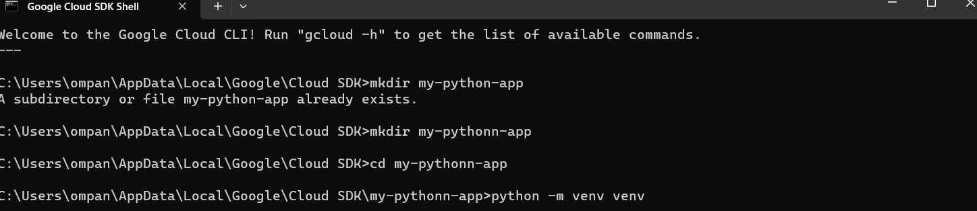



mkdir my-python-app

cd my-python-app

Step 3: Install Flask: Install Flask, a lightweight web application framework for Python.

pip install Flask

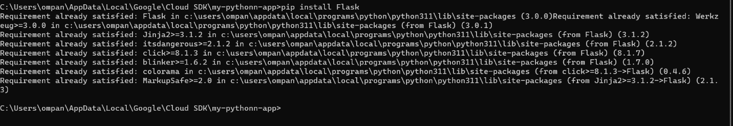

Step 4: Create the Flask App: Create a file named app.py with the following content:

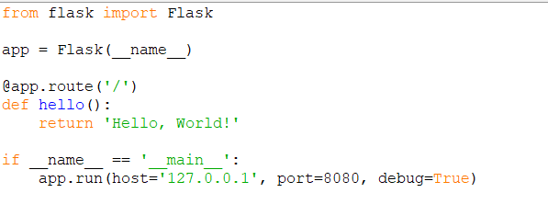

from flask import Flask

app = Flask(__name__)

@app.route('/')

def hello():

return 'Hello, World!'

if __name__ == '__main__':

app.run(host='127.0.0.1', port=8080, debug=True)

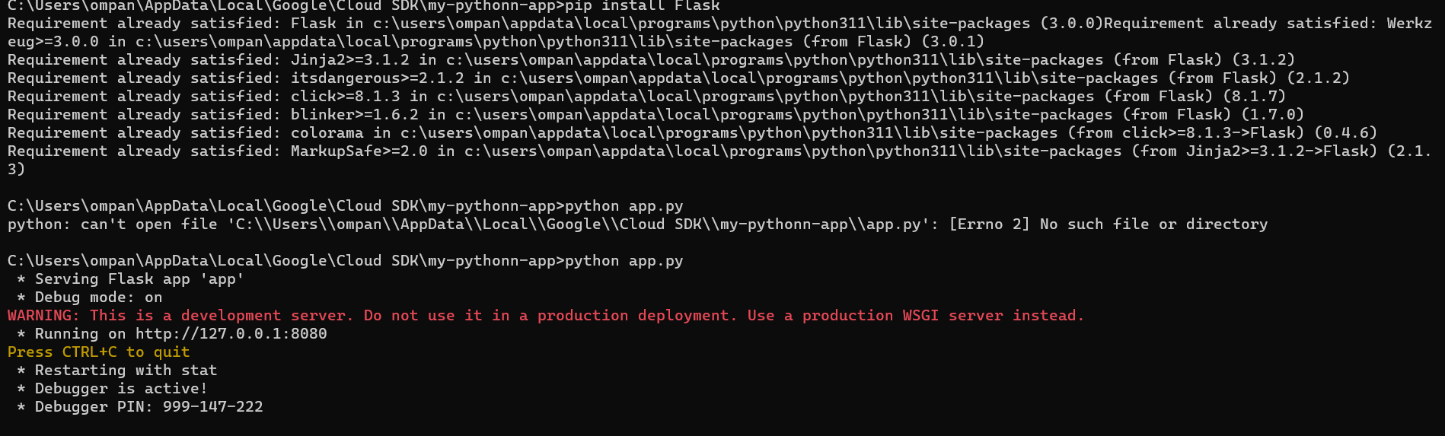

Step 5: Test the App Locally. Run the Flask app locally to make sure it works

http://localhost:8080 in your web browser.

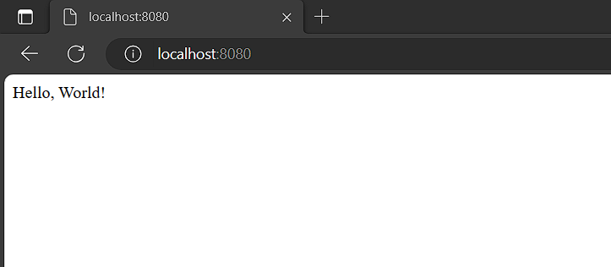

Step 6: Deploy to Google App Engine

Create app.yaml: Create a file named app.yaml in your project directory with the following content:

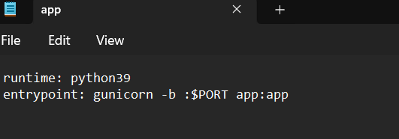

Deploy to App Engine: Deploy your app to Google App Engine.

Command - gcloud app deploy

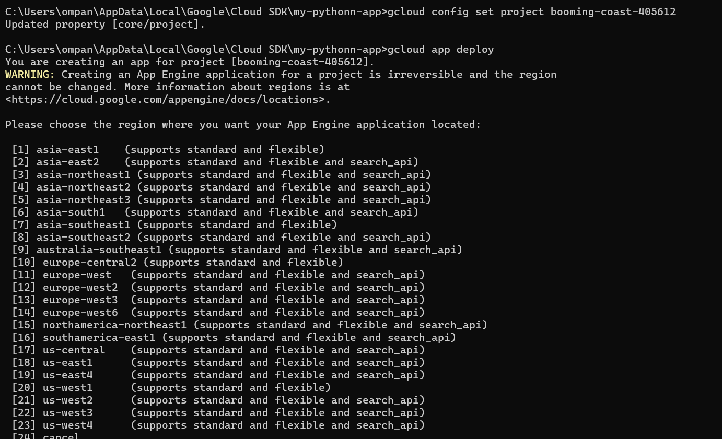

Step 7: Open the Google Cloud Console. Navigate to "IAM & Admin" > "IAM." Find the thatswhatshesaid976@gmail.com account. Click "Edit" (pencil icon) next to the account. Add the App Engine Deployer role (roles/appengine.deployer). Click "Save."

